Southern Tier Chapter of
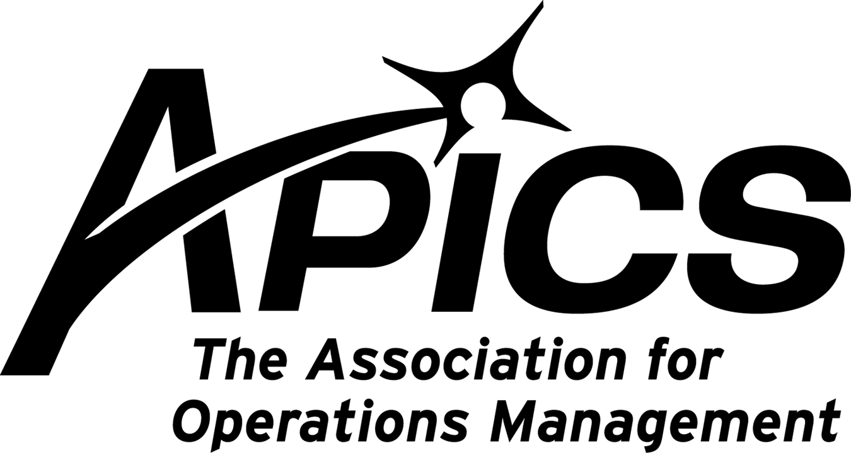
www.stapics.org

“Advancing productivity and innovation and competitive success.”

NO DINNER MEETING

Congratulations to ourselves – it’s our 35th anniversary!

If you’re planning a trip to the Caribbean in the near future, please bring back some coral gifts for our chapter. OK, if coral is no longer ecologically correct, then we’ll take jade. For those are the gifts assigned to the 35th anniversary.

The Southern Tier of NY Chapter of APICS was chartered on May 17, 1977. For the past 35 years, we have represented APICS to the people of this region. We’ve provided great supply chain and operations research education, internationally-known certifications, and local, national, and international networking.
We’re available 24/7 at www.stapics.org and also on Facebook.

Rather than having us dislocate our shoulders patting ourselves on the back, why don’t you consider joining our Board of Directors and make the next 35 years even better!

APICS News from Don Sheldon, Director of Education

Path to CPIM
APICS CPIM is a widely recognized, marketable credential. Most Materials related job openings today ask for or even require this earned designation. We as APICS members can be proud of this organizational achievement. If you are certified, make sure you maintain it. If you are not you should be considering it. To achieve certification, you must pass all of the following exams:

- Basics of Supply Chain Management
- Master Planning of Resources
- Detailed Scheduling and Planning
- Execution and Control of Operations
- Strategic Management of Resources

The Southern Tier Chapter does not currently have classes scheduled but we have 3 certified and willing instructors available and ready if the need arises. If we get 10 interested parties we will schedule any of the above classes. Classes offered in the past at BCC did not get funding this year. That does not mean that students willing to pay for the books and training will not have the opportunity to take classes. We would be excited if a local company would like to sponsor either a public or private course. That could be as simple as having 10 employees ready for a specific CPIM course. Contact us at dsheldon@sheldoninc.com if you are interested. As soon as we have 10 interested people, we will schedule a class in whichever CPIM class the membership needs. You do not have to be an APICS member to take the courses or to become certified.

Re-Certification

Recertification – Don’t forget that your certification expires after 5 years from either passing the test or your last Certification Maintenance Program update. All individuals who earned APICS CPIM, CFPIM, or CSCP designations are required to go through the Certification Maintenance Program.

When should you submit your maintenance application to APICS?
Certification maintenance cycles run in five-year intervals, commencing from the date of initial certification and ending on the last day of the month that initial certification was received.

Will APICS notify me when my application is due?
Notifications are sent via email to all certified individuals one year, 90 days, 60 days, and 30 days before their maintenance due date. Because notifications are only sent via email, it is imperative that APICS has current email addresses on file. If you change jobs, internet service providers, email providers, etc., you should always update your record with APICS to ensure that you receive all maintenance-related notifications. To ensure your contact information is up-to-date, access your APICS profile by logging into the APICS website using the box at the top right of this page and clicking My APICS or contact APICS Customer Service at service@apics.org.You can also call APICS Customer Service at 1-800-444-2742 or +1-773-867-1777+1-773-867-1777.

Am I required to retake the CPIM and/or CSCP exams in order to maintain my certification?
No, but if your certification status is suspended and continues to lapse for five years past your suspension date, you must take and pass the required certification exams again.

Will points be earned for responsibilities and activities completed as part of my full-time job?
No. The idea of the maintenance program is to demonstrate ongoing knowledge through continuous education.

Do I need to become a member of APICS in order to begin collecting maintenance points?
No. The APICS certification maintenance program is designed for both members and non-members. However, by becoming a member of APICS you will be able to claim 6 points per year for each year your membership is in good standing.

CSCP Training – I know CSCP has been a moving target and I apologize but lack of student interest and BCC and NYS grant issues have kept this off our calendar. I have 2 people interested and have not communicated with them for months but we cannot run a class with only 2 students. Let me know if you are interested and I will add your name to the list. We will keep trying to get this on the calendar in 2012 but there are no specific plans as of this writing. Again, if you are interested in any of the Southern Tier offerings, please contact me at dsheldon@sheldoninc.com. Thanks!

APICS Conferences - APICS conferences are a great venue to network and learn about new topics as well as traditional APICS materials and operations management topics. Here is the 2012 APICS conference schedule:

May 10-11, 2012 | Best of the Best S&OP Conference, presented by APICS and IBF, London, England

June 14-15, 2012 | The Best of the Best S&OP Conference, presented by APICS and IBF, Chicago, Illinois, USA
- October 14-16, 2012 | International Conference & Expo, Denver, Colorado, USA

I hope to see you in Chicago or Denver as I will be attending both of these conferences.

We’re on !!!
Come and visit, poke around, or comment on us! Our name there is “Southern Tier APICS”. It’s just another way
for us to keep in touch with our membership.

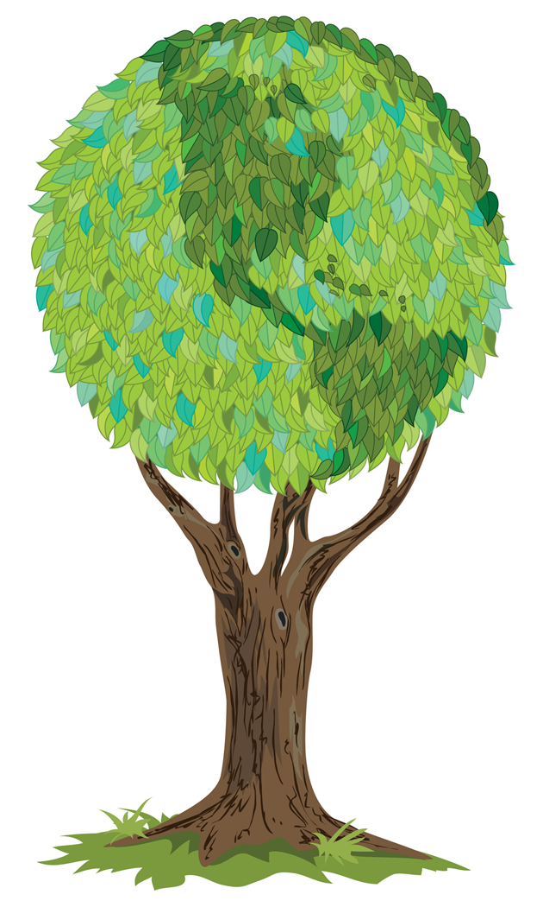

Board of Directors 2011-2012

President Director of Publicity
Dave Gardner Kelly Norieka
dgardner@akraturn.com Kelly.norieka@lmco.com

Executive VP /Director of Finance Director of Education
Steve Whited Don Sheldon
sjw6@meadwestvaco.com dsheldon@sheldoninc.com

Secretary Director at Large
Debbie Unkel Steve Stanchak
deb.unkel@raymondcorp.com steve.stanchak@infoprint.com

Director of Membership/Director of Chapter Standards/

Director of Online Publication Director of Student Relations
Lee Schechter Brian Arrnold
lschechter@stny.rr.com barnold@amphenol-aao.com

Director of Programming and Marketing Director of Communications
Michael LoSapio April McWeeney
Michael.LoSapio@SynergyResources.net april.mcweeney@mwv.com

Southern Tier APICS
PO Box 1107
Binghamton NY 13902-1107

